Name:

Year | Course:

Date: October 23, 2022 – **Deadline will be TODAY at 09:59AM**

This must be the name of your word document – LASTNAME_INITIAL(SE_MID3) **TUNGUL_RD(SE_MID3)**

**(Midterm – Activity 3) Razorvibe Hero**

Add the missing text and images using CSS. Kindly, compare the original example design to the completed one.

1. Problem#1: Incomplete Layout (Right)
2. Problem#2: Incomplete Layout (Left)
3. Problem#3: Missing button images and layouts

**Default output:**

 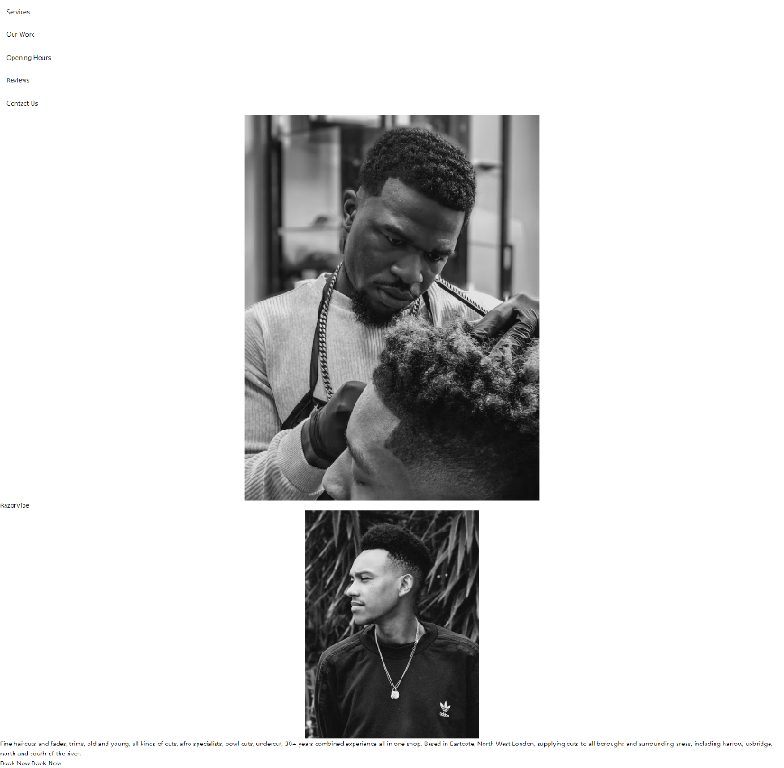

**Expected output:**

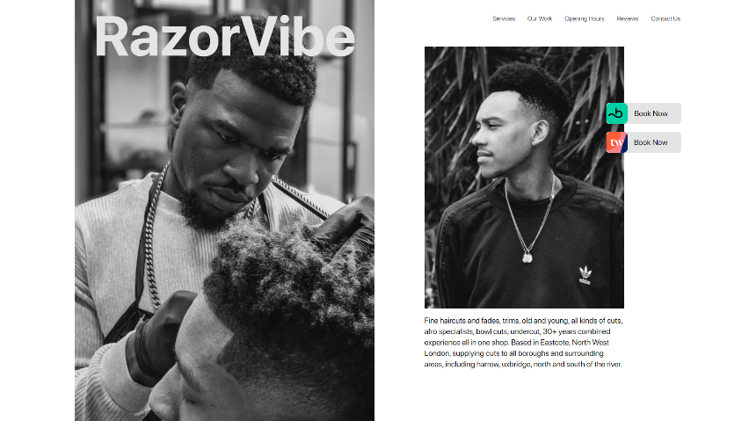 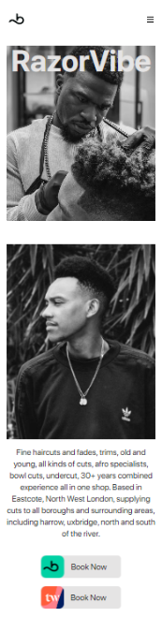

Explain the following problem on how you resolve them. DO NOT ANSWER IN CHORUS.

1. Problem#1: Incomplete Layout (Right)
2. Problem#2: Incomplete Layout (Left)
3. Problem#3: Missing button images and layouts

Goodluck and keep going! You can do it!

___________________

**Roseph Darl Tungul**

Instructor